Experiment No: 03
Name of the experiment: Implementing and verifying 2 to 4 decoders with Verilog and Gtkwave.
Theory: A 2 to 4 decoder is a digital circuit that takes two binary inputs A0 A1 and generates four outputs D0 D1 D2 D3 based on the input combination. The four outputs each correspond to each binary sequence of inputs A0 and A1. Verilog gives us power to implement the logic of this decoder with gate level modelling. The Verilog testbench can verify that the decoder is working and Gtkwave can simulate a graph for inputs and outputs.
Circuit Diagram:
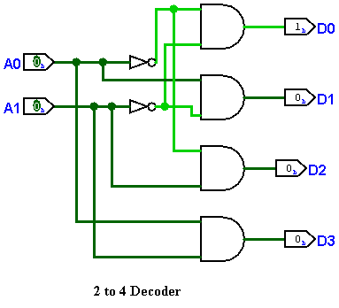
Truth table:
A1 | A0 | D0 | D1 | D2 | D3
0 | 0 | 1 | 0 | 0 | 0
0 | 1 | 0 | 1 | 0 | 0
1 | 0 | 0 | 0 | 1 | 0
1 | 1 | 0 | 0 | 0 | 1

Taking Min terms of the outputs we get,
$$D0=A0^{'}.A1^{'}$$
$$D1=A0.A1^{'}$$
$$D2=A0^{'}.A1$$
$D3=A0.A1$
So, in the main module we can implement these logical functions.
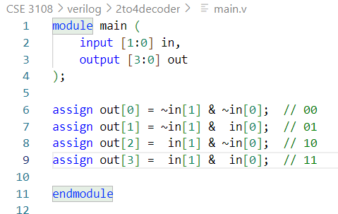
The Testbench can test the working of this module.
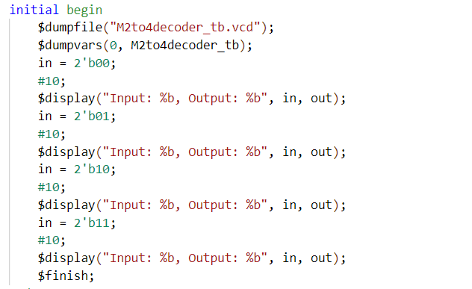

Output Screenshots:
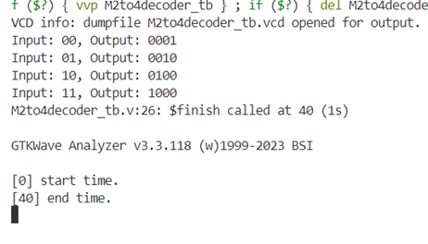
Image: Verilog Output
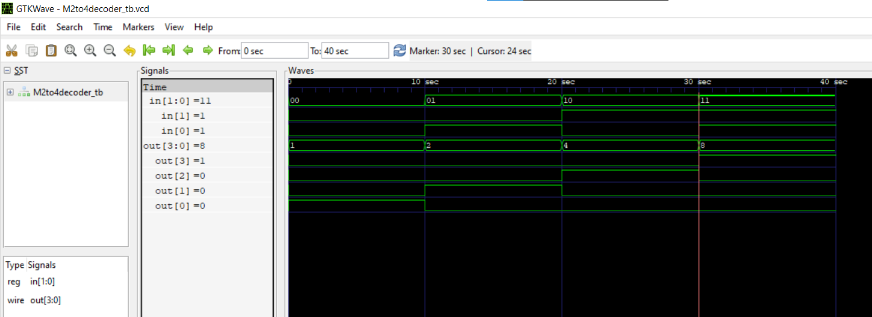
Image: Gtkwave Output

